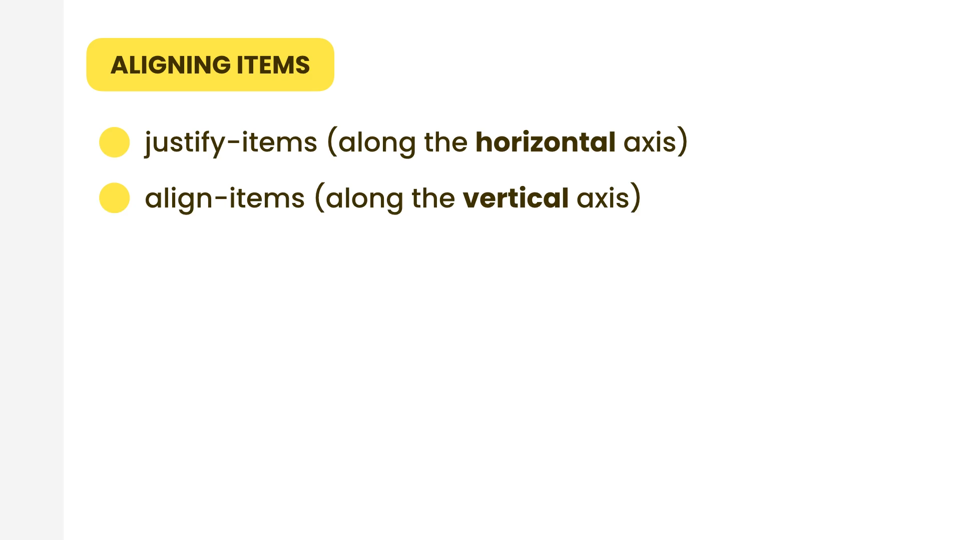

align-items

|  |  |
| --- | --- |
| Class | Properties |
| items-start | align-items: flex-start; |
| items-end | align-items: flex-end; |
| items-center | align-items: center; |
| items-baseline | align-items: baseline; |
| items-stretch | align-items: stretch; |

justify-items

|  |  |
| --- | --- |
| Class | Properties |
| justify-items-start | justify-items: start; |
| justify-items-end | justify-items: end; |
| justify-items-center | justify-items: center; |
| justify-items-stretch | justify-items: stretch; |

justify-self

|  |  |
| --- | --- |
| Class | Properties |
| justify-self-auto | justify-self: auto; |
| justify-self-start | justify-self: start; |
| justify-self-end | justify-self: end; |
| justify-self-center | justify-self: center; |

place-items: <align-items>/<justify-items>;

place-self: <align-self>/<justify-self>;

|  |  |
| --- | --- |
| Class | Properties |
| place-items-start | place-items: start; |
| place-items-end | place-items: end; |
| place-items-center | place-items: center; |
| place-items-baseline | place-items: baseline; |
| place-items-stretch | place-items: stretch; |

|  |  |
| --- | --- |
| Class | Properties |
| place-self-auto | place-self: auto; |
| place-self-start | place-self: start; |
| place-self-end | place-self: end; |
| place-self-center | place-self: center; |
| place-self-stretch | place-self: stretch; |